**SustainoLink Website Development Review and Feedback**

Company: Capital Numbers Infotech Pvt Ltd

Project Manager: Srijeeb Chakraborty

Contact: [srijeeb@capitalnumbers.com](mailto:srijeeb@capitalnumbers.com)

CONTENTS

[Milestone 2 (26-06-2024 to 26-10-2024) 2](#_Toc173934790)

[UI-Buyer Company User : (07-08-2024) 2](#_Toc173934791)

[Wireframe for the Freelancer consultant's dashboard (07-08-2024) 2](#_Toc173934792)

[Wireframe for the Consulting Company’s dashboard (05-08-2024) 3](#_Toc173934793)

# Milestone 2 (26-06-2024 to 26-10-2024)

## UI-Buyer Company User : (07-08-2024)

[https://www.figma.com/design/5NjTjaogGBQBpH7z9n1npE/CNP2096-SustainoLink-(client)?node-id=828-2&t=d9XRviMtbIWDyB7n-1](https://www.figma.com/design/5NjTjaogGBQBpH7z9n1npE/CNP2096-SustainoLink-(client)?node-id=828-2&t=d9XRviMtbIWDyB7n-1" \t "_blank)Follow Consistent colour pallet for the three parties- i.e,

* For freelancer Consultants - Pink
* Consulting Companies - Blue
* Buyer Company - Green

**Dashboard:**

* Consulting Companies & Freelancer consulting Pie Charts- the Colours used are confusing (the main purpose of the depiction is that it shows the total FC’s and CCs associated and past contracted each i.e, FC’s Associated and past contracted, CCs associated and past contracted)

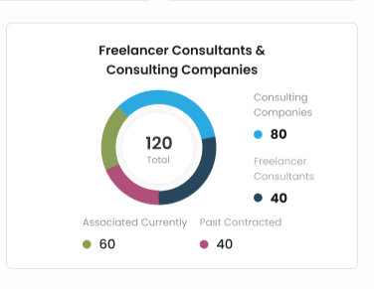

## Wireframe for the Freelancer consultant's dashboard (07-08-2024)

* Add Referrals received from Clients through LinkedIn, Facebook etcetc... ***(NEED TO CONFIRMATION FROM CN)***

**Dashboard:**

* The **Task and Work Progress- Pie** charts need to be changed to bar graphs like the one in timeline as they will be for each project! (can be shown together in a single depiction! As Completion rate is a part of Task status – can show the percentage rate of task completion within the Task status itself using different colours for in progress, not started and completed)

So, as Task Completion rate is a part of Task Status, replace Months from **X axis with Yaxis and Yaxis with Xaxis.**

* **Task Completion Rate:** Percentage of completed tasks vs. total tasks and
* **Task Status:** Breakdown of tasks by status, such as 'Not Started,' 'In Progress,' 'Completed’)
* Remove timeline dropdown from Task status
* Change the Graph Format not the trend analysis like how in the buyer company for
* Total projects
* Project Delivery

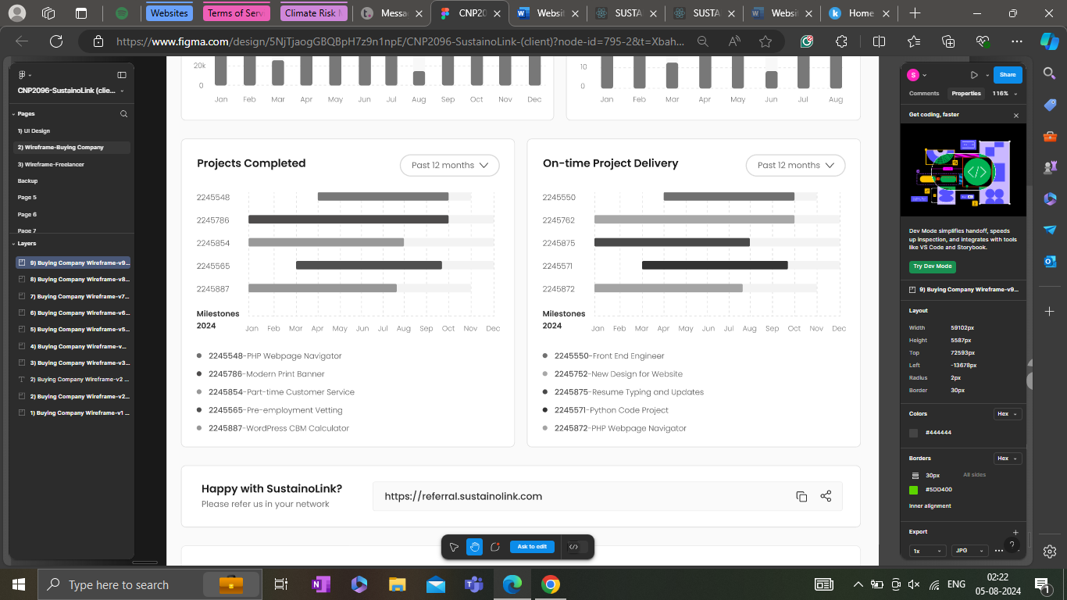

**My Projects:**

***Submit Quote:*** [CNP2096-SustainoLink (client) – Figma](https://www.figma.com/design/5NjTjaogGBQBpH7z9n1npE/CNP2096-SustainoLink-(client)?node-id=0-1&t=i8JhdkAB8WltyBFp-0)

* *The submission of quote (the process of view- Write a Quote --> submit quote / save as Draft)*
* *Add Save as Draft is missing*

**My Wallet:**

***Invoice & Payments***

* *Include Full address after name.* **- DONE**

## Wireframe for the Consulting Company’s dashboard (05-08-2024)

* **Consider consistent terminology in all the pages throughout all the milestones**
* **During the start i.e., after the login, a tour on how to use the dashboard should be created. (i.e, a pop-up option asking if they would like a tour of SustainoLink)**
* **The order of the profile section should be:**
  + Dashboard *(Similar to the Freelancer Dashboard)*
  + Inbox (*work and project mails & Conversations, chats)*
  + Browse Projects *(should direct them to Projects page)*
  + My Projects *(Projects in progress, draft, completed with Project name, clint name, invoice id, etc)*
    - Submit Quote *(to Quote and review projects)*
    - Manage Projects *(should have all the list of projects with sort, filter options)* 
      * On going projects *(Upload documents, download)*
      * Completed projects *(should have all the details of the project)*
    - *Documents (all the documents i.e. agreement copies, project documents etc are to be in a single place i.e. documents)*
    - *Timesheet (to Track and submit the timesheet if required by the company)*
  + My Wallet (*Invoice, Receipts, billing contact, payment preferences and subscriptions) maybe can include a analytics here in this page as min time of payment, deliverables* 
    - Invoices & Receipts with download option
    - Payments (list of payments received with date, project id, client details etcetc)
    - Subscription and Referral points details (we shall not get these active until the website gets established)
  + My Profile
    - Blogs & Publications *(should have the space for publishing as it should be linked to the Insights Page of the website)*
    - Past Contracted Companies *(should have the list of Companies with their project details, will even have their Contract List)*
    - Edit Profile *(Profile Picture, name, Short Description, DOB, Gender, location, nationality, Address, Email id, Phone number, Education, Certifications, Experience, Skill Set, Area of expertise, Sector, Languages, work location preference, LinkedIn link, Resume, Portfolio, Password and security, Notifications (would they like to receive notifications for inbox messages, projects, payments, new blogs, tips on enhancing account and updates(just enable disable icon)), bank account details, referral code/Link and delete account )*
    - Support Center

**\*\*\*\***